CENWP-OD-B 06/08/12

MEMORANDUM FOR THE RECORD 12BON16 MFR

SUBJECT: Lamprey mortality at Bonneville’s Adult Fish Facility (AFF)

On 08 June, NOAA and University of Idaho researchers contacted Project Fisheries to report a dead adult Pacific lamprey in the AFF. The fish was discovered on the Valve 15 return pool drain trash rack and appeared to be quite decayed. The mort was released to the tailrace. Information collected is provided below:
- Species – Pacific lamprey (Entosphenus tridentatus)
- Origin – Unknown
- Length – Unknown
- Marks and tags – None
- Marks and Injuries found on carcass – No notable marks or injuries
- Cause and Time of Death – Unknown
- Future and Preventative Measures – Not applicable

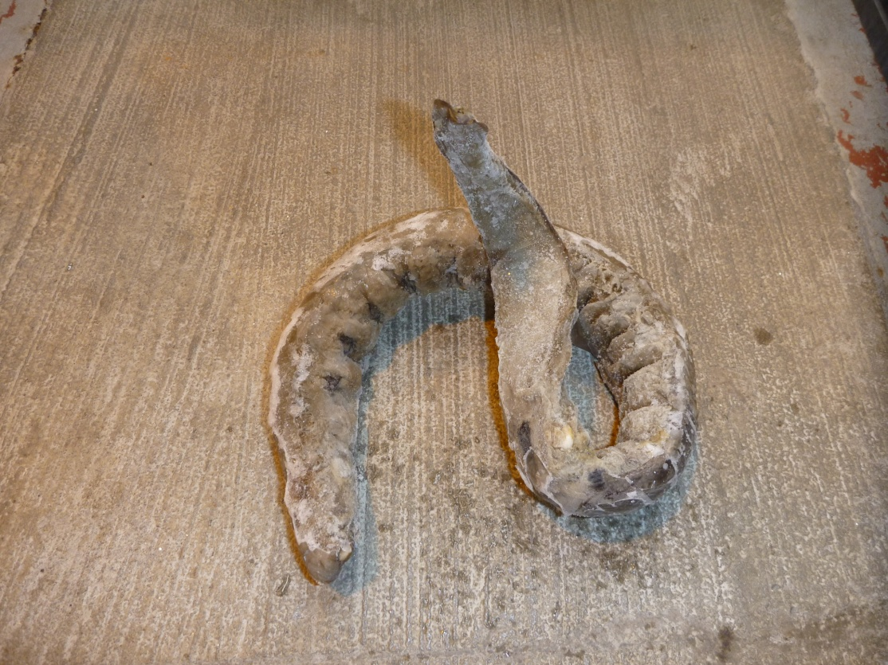

Sincerely,
Bonneville Project Fisheries

